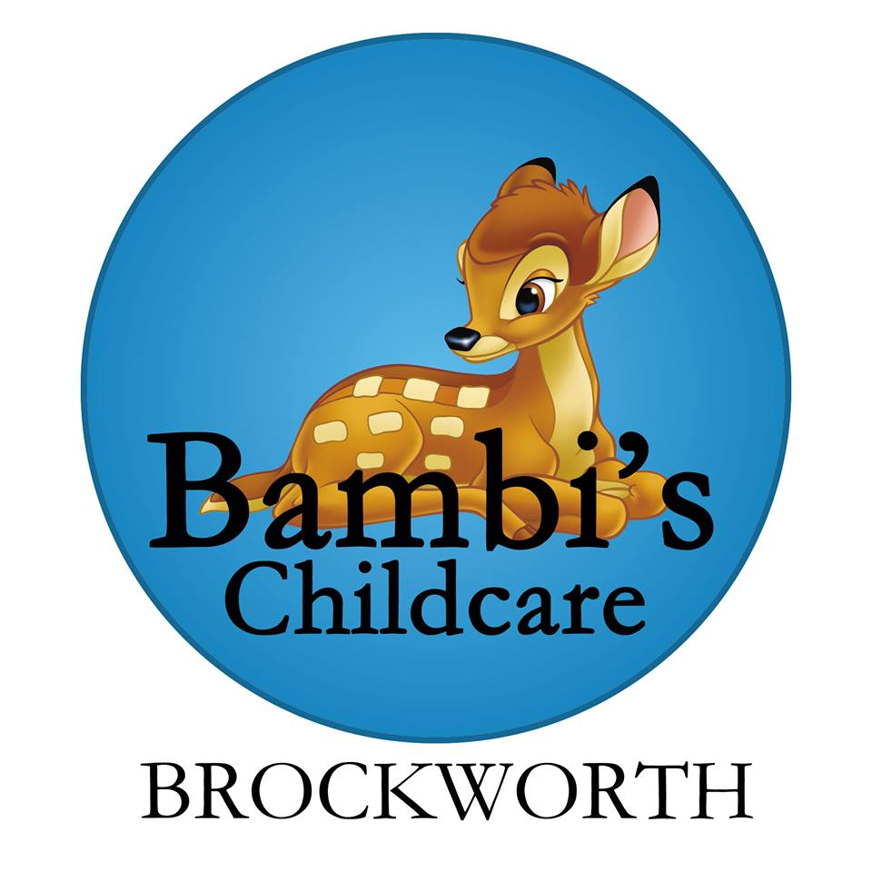

Live~Laugh~Love
Safeguarding/child protection

Safeguarding is EVERYONES responsibility and it refers to a range of measures taken to ensure the safety of all children and promote their wellbeing. Bambi’s childcare recognises the importance of ensuring there are policies and procedures in place to deal with any safeguarding issues that may arise and outline the appropriate steps that will need to be taken in event of any concerns.

Abuse, concerns, training and Responsible person (DSL)

Safeguarding action may be needed to protect children from the following forms of abuse
- Physical
- Emotional
- Neglect – environmental, educational, medical, physical/deprivation of needs, supervisory, emotional
- Sexual

Our aim is that all staff at Bambis will undergo relevant Safeguarding training with an official outside agency within 3 months. However if this is not possible due to dates and training being fully booked, managers will ensure that staff are given in house training, this will include access to a safeguarding folder and quizzes at monthly staff meetings, posters in the office and staff bathroom. Staff have been given an Acronym, PENS to help remember the 4 forms of abuse mentioned above. Acronym
All staff are aware of the child protection process and know that the flow charts can be found on the wall in the office and on the back of the bathroom door upstairs.
Staff also know that if they have any concerns about a child or a child’s family then a concerns form needs to be written and the DSL informed, it also needs to be signed by all involved and filed for confidentiality. There may be a range of reasons that a practitioner is concerned about a child. It may be physical marks on the child’s body, something the child has said or something the practitioner has witnessed. All these reasons are valid in logging a concern about a child’s welfare. Concerns forms can be used to evidence a child who may be acting differently to usual but hasn’t made a disclosure. This can enable the practitioner to gather a little more evidence before logging an official concern.

Recognising the signs of abuse and neglect in children who have special educational needs.
There are many different barriers that we face when recognising signs of abuse of a child that has an impairment/ disability, this is because disabled children experience greater and created vulnerability as a result of negative attitudes and unequal access to services and resources and because they may have additional needs relating to physical, sensory, cognitive and/ or communication impairments. If we feel that there is possibility or the likelihood of posable abuse their disability will not mask or deter us from carrying out any investigations. Any such concerns for the safety and welfare of a disabled child would be acted upon in the same way as that for a non-disabled child.

Peer abuse
At Bambis we continue to ensure that any form of abuse or harmful behaviour is dealt with immediately and consistently to reduce the extent of harm to the young person, with full consideration to impact on that individual child’s emotional and mental health and well-being. Children and young people may be harmful to one another in several ways which would be classified as peer on peer abuse, the types of peer on peer abuse are
- Physical abuse e.g. (biting, hitting, kicking, hair pulling etc.)
- Sexually harmful behaviour/sexual abuse e.g. (inappropriate sexual language, touching, sexual assault etc.)
- Bullying (physical, name calling, homophobic etc.)
- Cyber bullying
- Initiation/Hazing
- Prejudiced Behaviour
We will deal with a situation of peer abuse immediately and sensitively. It is necessary to gather the information as soon as possible to get the true facts around what has occurred as soon after the child (ren) may have forgotten, to do this we will ask open ended questions to all children involved.
There may be many reasons why a child harms another and it is important to understand why a young person has engaged in such behaviour.
We will then decide on what course of action to take next this maybe new topics introduced covering bullying or on a specific area or a my-plans being put into place for both/ all children involved.
We will then inform the parents/ carers of all involved about the incident and talk about the actions we would like to take to prevent this occurring again, any plans will be agreed by the parents/ carers before they are used.

The overall responsibility of safeguarding falls to Victoria Hopkins who is the designated safeguarding lead (DSL) If Victoria is not on site, she is always contactable on her mobile (Her number is stored on the works landline)
If you suspect any abuse the procedure is as follows.
- Record them on a concerns form and then talk to the DSL about your concerns. (These can be found in the Red folder in the hallway labelled accident, existing injury and concerns forms.)
- Talk to parent – Unless otherwise advised by your DSL
- Record any findings or comments made by children or parents, also on a concerns form.
- Contact any necessary agencies. You will find all this information on the Referrals to social care and child protection flow chart. (These can be found in the office, back of the bathroom door upstairs and in the safeguarding folder.)
- All records of referrals must be retained, and evidence of agreed actions must be taken promptly to avoid further harm.

ICT
Filters and controls are in place on the tablets. This is to ensure that all children are protected and helped to keep themselves safe from bullying, racism, homophobic behaviour, sexual exploitation, grooming and radicalisation. Staff will be made aware about the dangers of using ICT and technology during monthly staff meetings.
To further safeguard, Staff will be invited to undergo online training about child sex exploitation and prevent duty. (Channel)
Bambis ensures that all staff, visitors and parents do not use their phones in and around the setting and around children. There are clear signs inside and outside of setting to support this. Staff are required to leave their own phones on silent in the office as well as smart watches unless the notifications are turned off, during working hours but can use them during their breaks either in the office or outside. Visitors are asked to also leave their phones in the office on visits but can use them for calls only.
Bambi’s have a ‘work’ mobile to take on outings that only enables calls and text and only has Bambi’s number stored.
Bambis will also ensure that any visitors to the setting will have their ID checked at the gate and that they are not left alone at any time with any children. This is to ensure children are again protected from harm including being drawn into extremism and abuse.
All photos of children displayed will only have first names on them and no photos will be displayed inside the nursery, on our website or on our face book page without parental permission. Parents must also understand that from time to time their child may appear in another child’s learning journey, for example in a group activity. Staff will endeavour to keep this to a minimum.

Prevent
From 1 July 2015 all schools, registered early years childcare providers and registered later years childcare providers are subject to a duty under section 26 of the Counter-Terrorism and Security Act 2015, in the exercise of their functions, to have “due regard to the need to prevent people from being drawn into terrorism”. This duty is known as the Prevent duty, this can be found in the Official documents folder in the office. Staff at Bambi’s are vigilant in looking for changes in behaviour from children and their parents/carers. We also look for changes in appearance in mothers in case lavish gifts are being bought.

Tracking
At Bambis we further safeguard children by signing them in and out daily and tracking levels of attendance monthly and looking for patterns of nonattendance. Other ways we safeguard children is by doing accident and medicine forms and having existing injury forms for any injury’s that have occurred outside of setting. These forms are filled out by relevant staff and/or parents, signed and dated, tracked weekly and kept in child’s personal folder.
At the point of children leaving to go to school or another setting a copy of all existing injury and concerns forms will need to be sent to the appropriate setting, and the originals kept for 12 months. If a child is removed and does not go to another setting, we must send forms to the local authority.
Bambi’s childcare will record all nappy changes including times and sleep times into their diary (upstairs children only) however sleep checks will be carried out every 10 minutes and recorded in a sleep record book.

Children’s attendance
All children’s attendance is monitored closely. If a child is missing from the setting the parent/ carer will be contacted and asked to give an explanation as to why this is, this will then be documented. Continued absent from the setting may result in a meeting with the DSL to discuss and barriers or issues that maybe affecting the child or family and we will try and resolve these.
If this is still not resolved, we will then follow the child protection process.

Risk assessments
Procedures are also in place to minimise any identifiable risks to children in or out of setting, we do this by having risk assessments for all rooms, both gardens and outings to the park. These can be found in the risk assessment file in the hallway. These are carried out and signed off primarily by AM staff but continued throughout the day by all staff.
Risk assessments are reviewed monthly by management.

Risk assessment processes identify 5 steps that you need to take:
♣ Identification of risk or hazard - where is it and what is it?
♣ Decide who is at risk and how - for example childcare staff, children, parents, cooks, cleaners.
♣ Evaluate the risks and decide on precautions - can you get rid of the risk altogether, if not how can you control it?
♣ Record your findings and implement them - prioritise, plan of action if necessary.
♣ Monitoring and review - how do you know if what has been decided is working, or is thorough enough?

The components of providing a safe environment include:
♣ The physical environment - the actual building in which care is provided. Indoor and outdoor areas where children learn, play and develop must be accessible for users whilst maintaining levels of security that keep children safe and protected from harm. Bambis ensures this by daily risk assessments, having a double lock gate out of reach of children in the back garden, a 6ft high gate that blocks of any view to the garden from the main road and a fence that encloses the front garden area from the main road and neighbour’s driveway with an access gate secured by a combination lock strictly for parents. (Please see security policy)

♣ The people - those providing care are “suitable” persons (as defined in the Statutory framework, section 3 Welfare Requirements) and others who have contact with the children and premises are appropriate to do so. Bambi’s childcare will ensure safer recruitment, through relevant training, in line with the revised EYFS statutory requirements and current legislation where;
- All staff will obtain a minimum of level 2 and/or work towards a level 3
- Have undergone an enhanced DBS check
- Disclose if they are taking any medication.
At Bambis staff are aware that they have a duty of care to pass on any information related to cautions, court orders, reprimands or warnings or found guilty of committing any offences.
All this information, including qualifications can be found on a single central record on the wall in the office. Bambis will also obtain references for successful candidates which are stored in personal staff files.
At Bambis all staff are deployed appropriately around the setting to ensure correct ratios are upheld.
Bambi’s also ensure that a robust strategy is in place for supervisions of staff, these happen every 6-8 weeks and dates are arranged in advance. These can be found on the office notice board. Staff also sign to evidence they have attended. During supervisions Staff development is discussed. All previous and upcoming training is recorded on a training from available on the staff notice board.

♣ Documentation – Bambis has clear policies and procedures and records that support all of the above. These can be found in the office in the policy folder for staff and in the hallway in the policies for parent’s folder and also on our website. All staff and regular visitors have been given a copy of the child protection process, allegations management, safeguarding policy and lost child policy as a booklet to keep, read and understand.

COVID 19
In line with the government guidelines, we have introduced a system of control. Staff are not required to wear a face covering whilst working with the children unless they wish to, however they are required to wear one whilst answering to door. All adults and children are required to have their temperature taken at the door and if it is above 38c they will be refused entry and asked to have a test done.
In the event of any children coming down with COVID-19 symptoms whilst at nursery that child will be brought to the office where a member of management will sit with them whilst waiting for parent/ carer to collect, the member of management will be required to wear a face covering, gloves and an apron for protection.
All rooms already have a tissue station with a catch it, bin it, kill it sign. Children and staff are required to wash their hands regularly, each sink has a timer and a song to promote good hand washing. In the event that we have a positive test Carla or Victoria will call department for education helpline for advice, in the event we have two or more cases within the setting public health England will be contacted.

