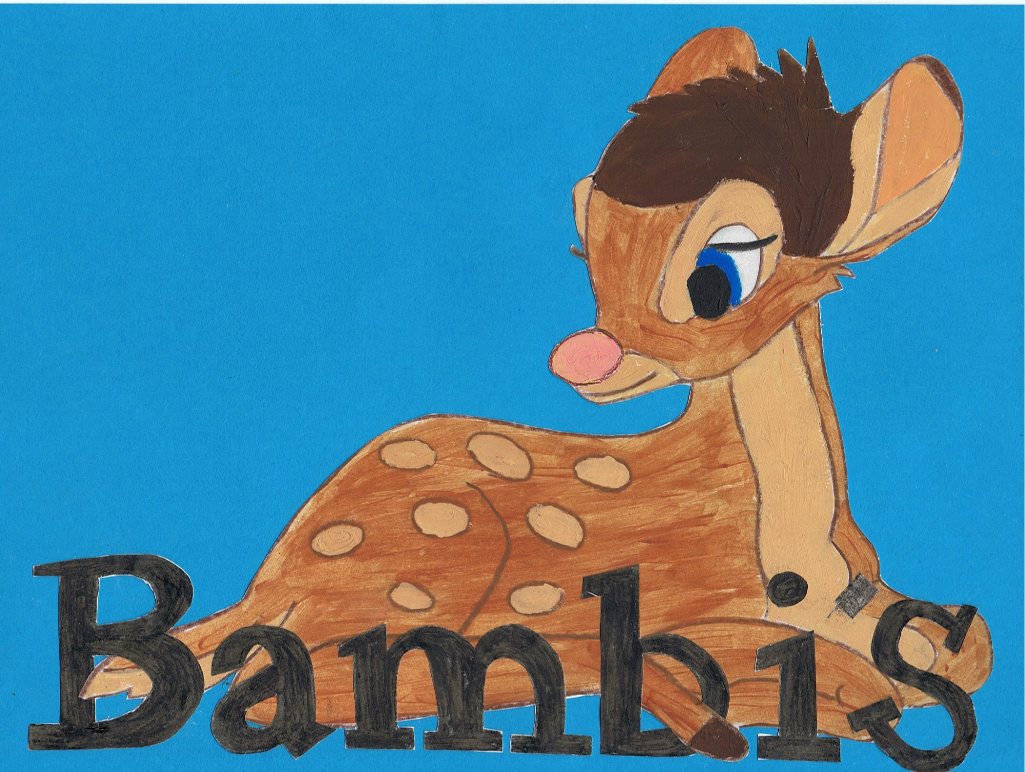

Live~Laugh~Love
Induction

The revised EYFS statutory framework says providers must ensure all staff receive induction training to help them understand their roles and responsibilities. This must include information about emergency evacuations, safeguarding, child protection and other relevant policies.

All new staff will:
- Complete an induction process given by management to familiarise them with the organisation’s policies and procedures and the responsibilities of the post, including safeguarding, fire evacuations and health and safety.
- Attend a recognised safeguarding awareness course as soon as possible and no later than six months after taking up their post, unless they have a relevant one.
- Complete a probationary/trial period (usually 3 months)
- Complete a fire evacuation procedure within 1 month of employment.

Monitoring and appraisal

All new staff will have access to support from either Carla or Lucy at any time and receive a formal supervision at the end of their probation period. At regular intervals Bambi’s will arrange appropriate times for all new and existing staff to be given the opportunity to receive and provide feedback relating to their role, these are called supervisions.

Supervision should provide opportunities to;
- Discuss any issues – particularly concerning children’s development or well being.
- Identify solutions to address issues as they arise,
- Receive coaching to improve their personal effectiveness.
- Discuss any training opportunities.

