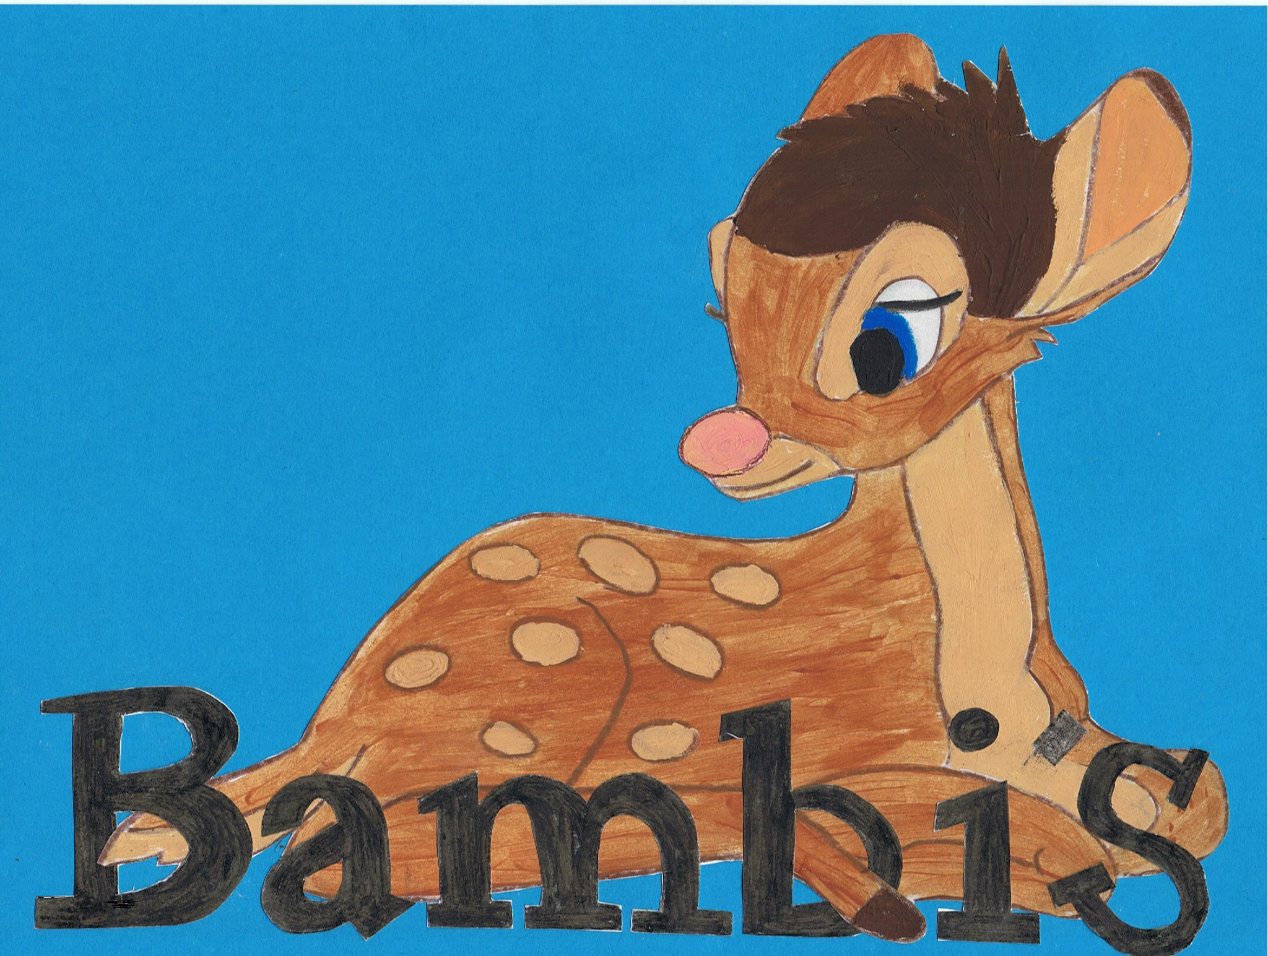

Live~Laugh~Love

No smoking policy

This policy has been developed to help provide a healthy, safe and comfortable environment at Bambi’s Childcare by intending to protect everyone against the effects of second-hand smoke and promote health in the workforce.

Breathing in second-hand smoke leads to;

- A 24% increased risk of contracting lung cancer in non smokers.
- A 23% and 25% increased risk of heart disease in smokers and non-smokers respectively.
- Cause or trigger asthma.
As well as many other illnesses and minor conditions.

Section 2 of the Health and Safety at Work Act 1974 places a duty on employers to provide a working environment for employees that is:

"..Safe, without risks to health, and adequate as regards facilities and arrangements for their welfare at work."

The Health Act 2006 prohibited smoking (smoking or being in the possession of lit tobacco, anything containing tobacco or any other substance) in all public premises including workplaces and work owned/hire cars.

The department of health have introduced a new law, from Oct 1st 2015 it is illegal to smoke in a car (or other vehicle) with anyone under 18. The law changed on 1 October 2015, to protect children and young people from the dangers of secondhand smoke. We will be vigilant towards this.

Bambi’s Childcare does not allow smoking on or around its premises by staff, parents or carers. Any staff that wishes to smoke during work hours can do so in their lunch break, however they must go to a place out of sight and they are also asked to remove their uniform as toxins in smoke can stay on clothes for up to 2 hours, and ensure they thoroughly wash their hands on their return to work.
Any staff that do not comply will receive disciplinary action. Any parents/carers that smoke within nursery grounds will endure a £10 fine.

