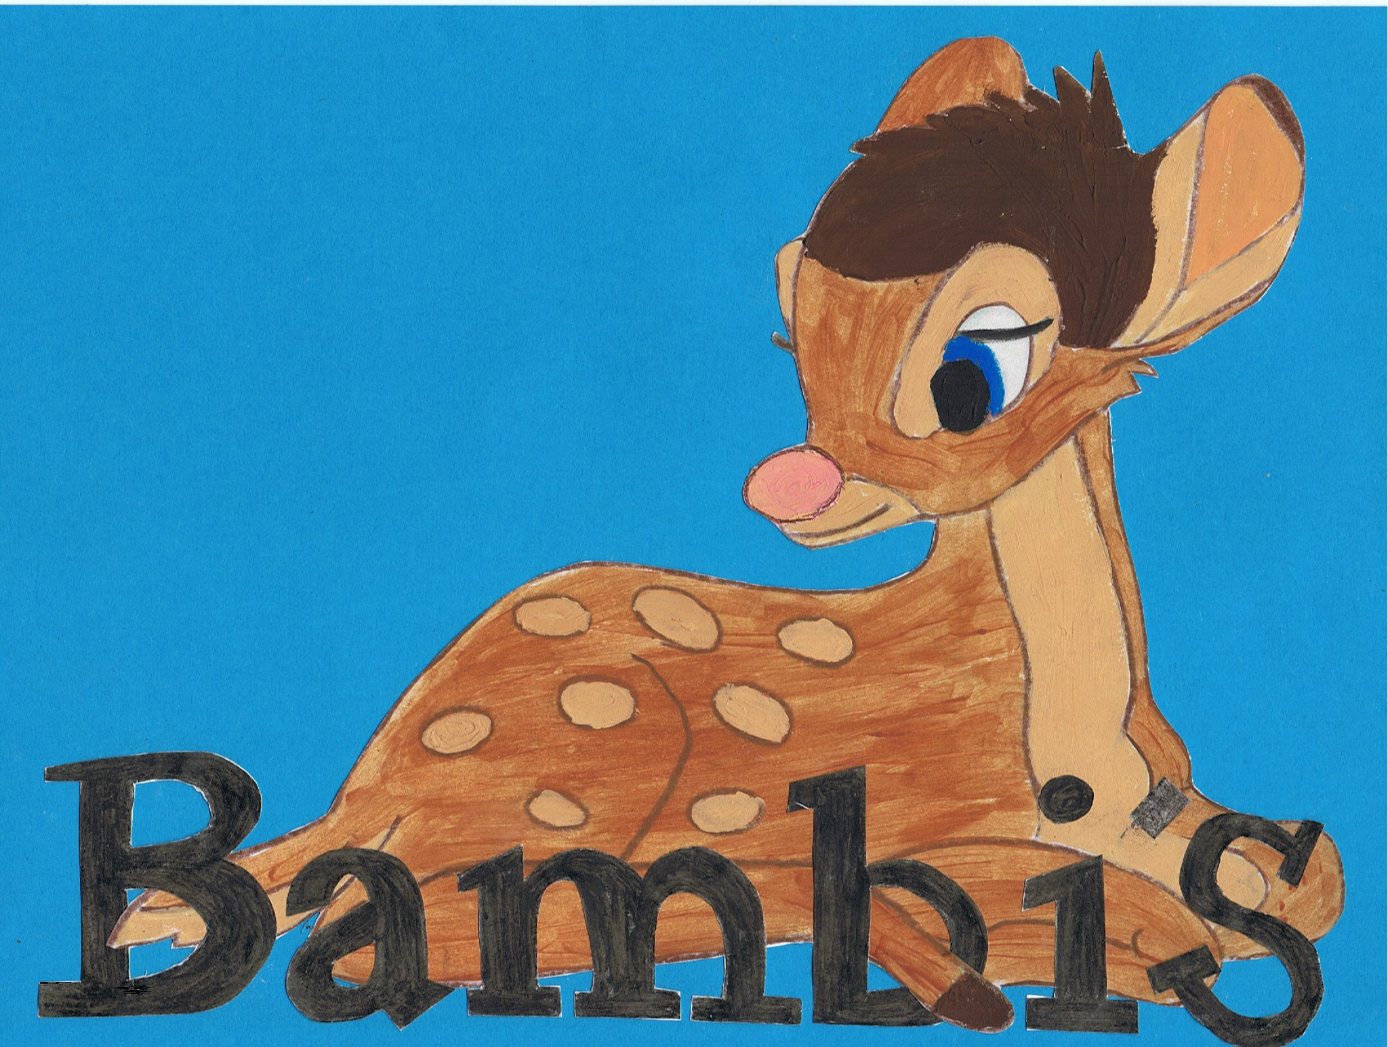

Live~Laugh~Love
Interview policy

All short listed applicants will be required to complete a standard application form during interview with managers and asked to spend a little time with the staff and children.

Candidates are required to supply the following information:

  - A current CV which states a full history of any paid or voluntary positions working with children, with start and end dates and reasons for leaving. A statement of the personal qualities and experience that demonstrate the applicant’s suitability for the position and how she/he fulfils the person specification. Contact details of at least two referees, one of whom should be a previous employer.

  - Current and any former names, address and other contact details.

  - Information on relevant academic or vocational qualifications and details of the awarding body.

  - The applicant will be required to make a self-declaration of any convictions, cautions and warnings, including those regarded as ‘spent’, declare any medications they are or have been taking, and also if they have been receiving any counselling, under the revised EYFS statutory requirements. In addition applicants must also indicate whether they have had any involvement in a Police/Children’s Social Services enquiry involving children under the age of 18 or they have been subject to any disciplinary sanctions by any other regulatory body or previous employer.

All applicants will be assessed against the criteria contained in the person specification and feedback from staff. Any concerns and unexplained gaps from the application forms will be noted and addressed with the applicant during interview.

