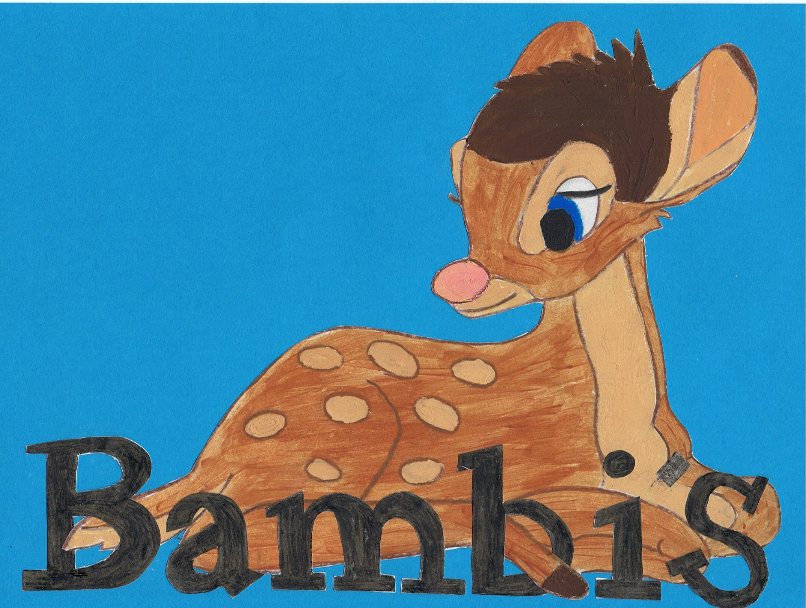

Live~Laugh~Love
Holidays Policy

The holiday year runs from 1st January to 31st December. You will be entitled to 28 days paid holiday each year including public bank holidays pro rata, depending on the amount of days you work.
Employees who join during the year receive a proportion of the full holiday entitlement; dependent upon how much of the year is remaining form the date that employment started.
Holiday must be cleared by Carla firstly before you go ahead and book them as we can take no responsibility for holidays lost because they were booked before checking available dates.
It is essential that you share this with partners in case of any surprise holidays being booked.
Holidays must be BOOKED, not taken, by 1st October. Holidays will be lost if not booked by this time.
Guidelines for taking holiday
- All holiday requests should be made well in advance – for a week off we require 3 weeks’ notice and for a day off we require a weeks’ notice.

- They must be cleared with Carla firstly and Lucy in Carla’s absence, before any commitments are made.

- It is important that you take your full holiday entitlement during the holiday year. Holiday entitlement cannot be carried into the following year.

- There will be no payment in lieu of any holiday not taken.

- No more than one staff member off at any one time for a week period.

