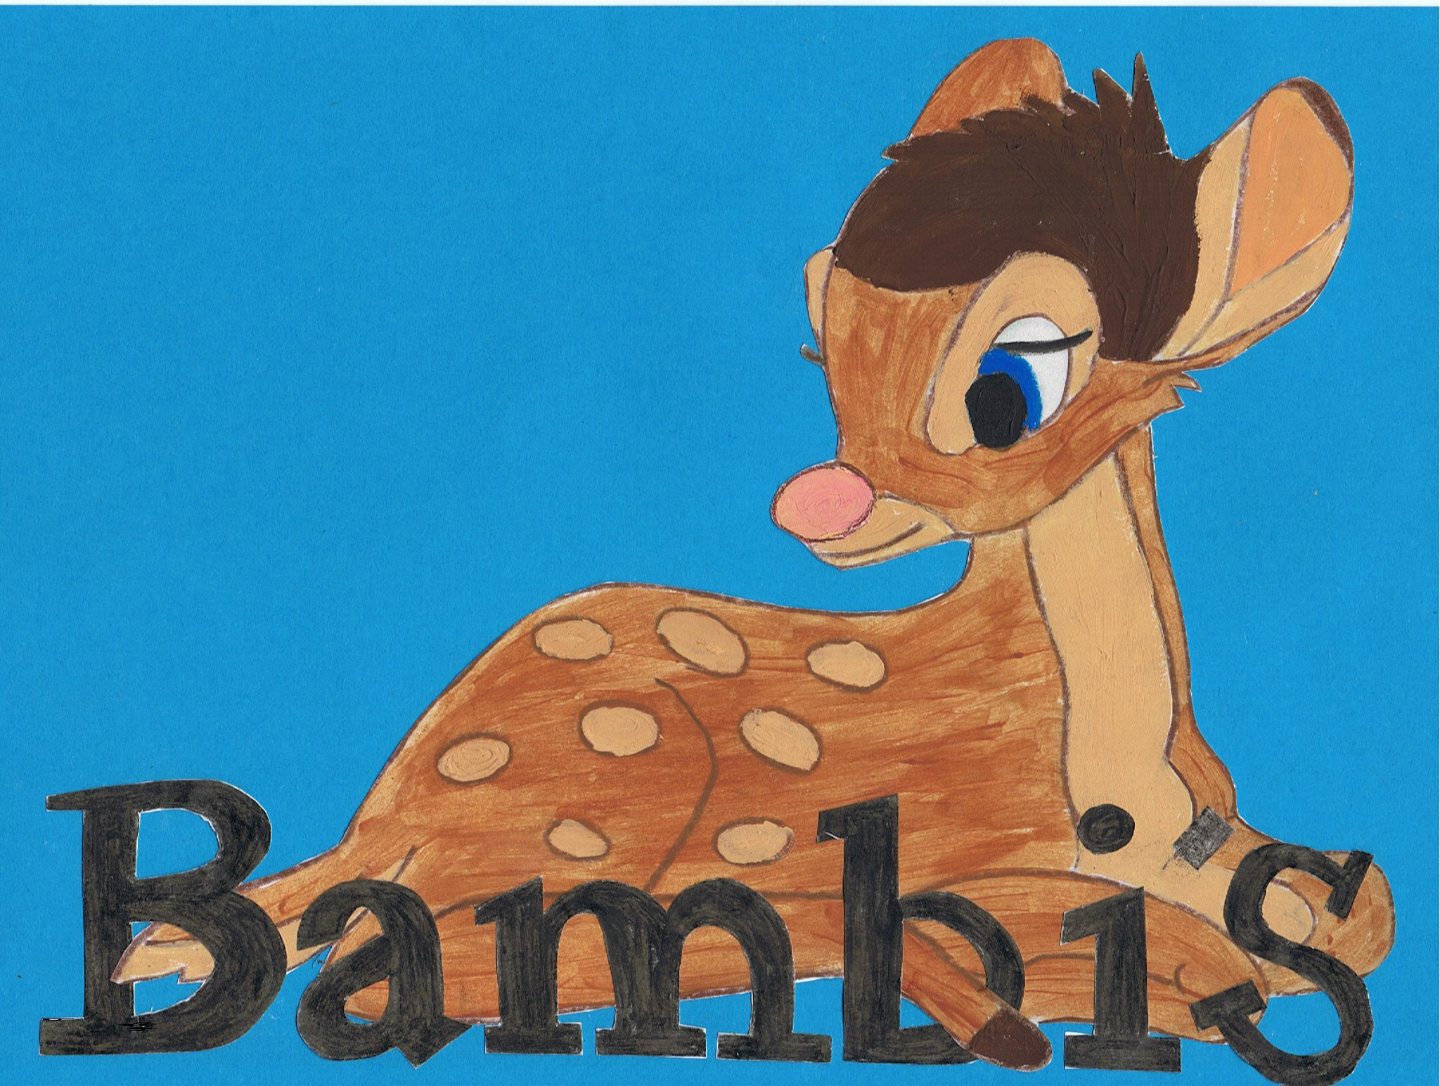

Live~Laugh~Love

Health and safety policy

Bambi’s childcare is a small homely setting. We endeavour to promote a home from home feel. In line with this we have a legal duty to comply with the Health & Safety at Work Act 1974. Bambi’s has a responsibility to provide a safe environment for all children, staff and parents and the Managers are responsible for health and safety matters concerning the nursery premises.
Your designated health and safety officer is; Emma Pedley and Katie Stevens in her absence.

All staff must be aware of potential hazards within the nursery and the surrounding environment. All rooms have risk assessments and signing sheets. Staff will risk assess each room before any children enter the premises and throughout the day by the accessible risk assessments, and actively protect children from hazards.

It is our aim to provide all staff with first aid training. All accidents and any incidents are recorded individually and stored confidentially. Any accidents are accurately notified to the parent/carer at when they pick up the child/ren.
Hygiene rules relating to bodily fluids are followed with particular care and all staff are aware of how infections can be transmitted and will follow the relevant procedures. (Refer to infection control poster for guidance on illnesses.)

Bambi’s aims to:
- Involve and motivate nursery staff and children in all matters concerning Health & Safety.
- Prevent accidents, injuries and ill-health and to identify and eliminate hazardous situations.
- Achieve a high standard of occupational health, safety, welfare and hygiene.
- Control situations likely to be hazardous to health and safety in the nursery or cause damage to persons or equipment.
- Provide a safe, healthy environment.

