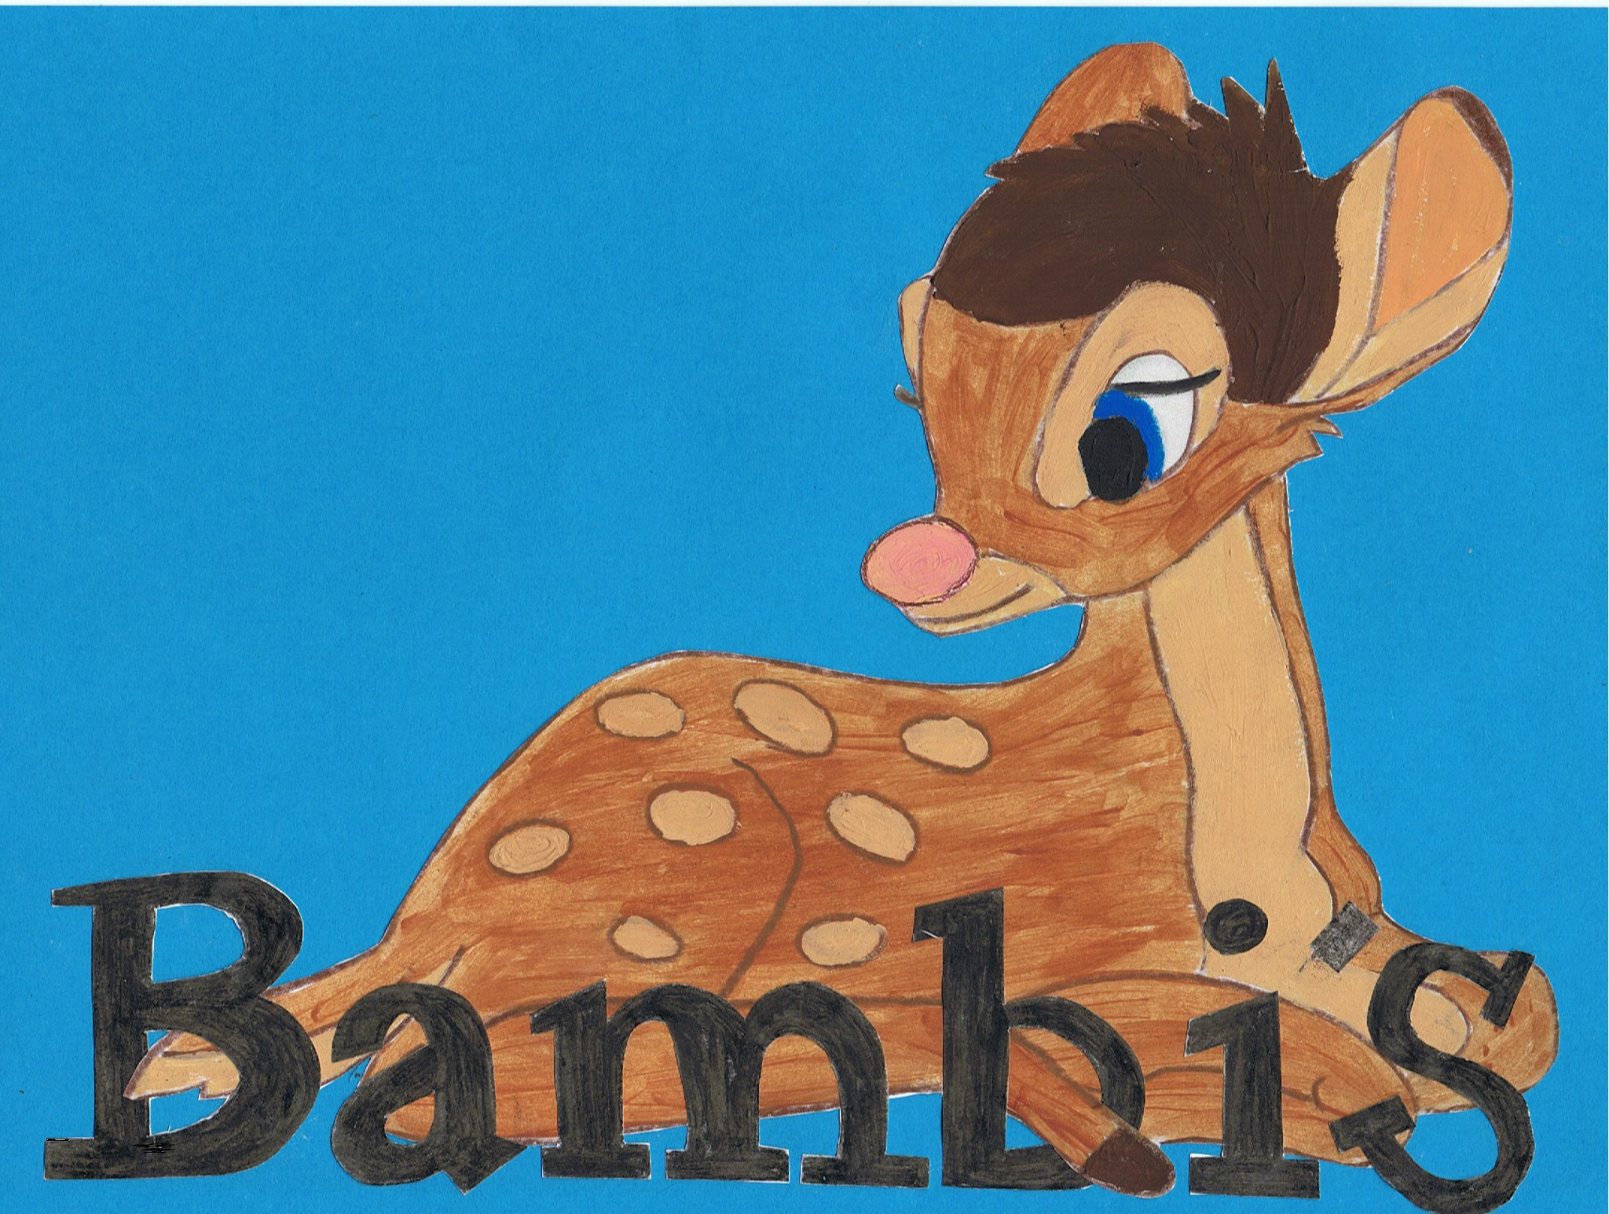

Live~Laugh~Love
Equality and inclusion Policy
Part 1.

Bambi’s Childcare are committed to caring for and respecting every child, irrespective of social class, gender, religion, race and disability, to encourage and achieve his/her full potential.

We will strive to achieve this by:
- Providing activities and experiences where children can express feelings in a non-gender specific way and to challenge stereotypes e.g. allowing all children to play with dolls and accessories or cars.
- Encouraging children to explore and talk about traditional and non-traditional roles e.g. mummies sometimes look after children and daddies go to work and also some mummies and daddies both work.
- providing activities where children talk about themselves and their families and any traditions they may celebrate and then extending these discussions to introduce other cultures, religions and disabilities
- Providing equipment within Bambi’s that will challenge stereotypical roles e.g. play kitchens, Dr’s set and offer more freedom for children to express their feelings in a non-judgmental environment.
- Providing equipment where all these differences are shown in a positive way such as: books, stories, puzzles and posters.
- Liaise with parents and use home language as a means of communication.

All measures will be taken to ensure that any child with special needs is offered the same experiences as other children within the group.

Staff are encouraged to become aware of their own prejudices, biases and preconceptions in order to prevent them interfering in their work.

Live~Laugh~Love

Equality and inclusion Policy
SEN

At Bambi’s Childcare we are committed to the inclusion of all children. All children have the right to be cared for and educated to achieve the best possible outcomes, to share opportunities and experiences and develop and learn alongside their peers. We provide a positive and welcoming environment where children are supported according to their individual needs.

We recognise that some children may have additional needs that may require particular help, intervention and support. These needs may be short-lived for a particular time in the child’s life or may require longer-term or lifelong support. At all times we will work alongside each child’s parents and any relevant professionals to share information, identify needs and help the child and their family access the support they need.

The role of the Special Education Needs Co-ordinator (SENCO)

The role of the SENCO is to provide a lead for staff in relation to SEN and disabilities and to make sure procedures are followed, appropriate records kept and parents are involved. The child’s practitioner (key person) will normally remain responsible for working with the child on a daily basis and for planning and delivering an individualised programme. The particular responsibilities of our SENCO are:
- ensuring all practitioners in the setting understand their responsibilities to children with SEN and the setting’s approach to identifying and meeting SEN
- advising and supporting colleagues
- ensuring parents are closely involved throughout and that their insights inform action taken by the setting
- Liaising with professionals or agencies beyond the setting.

Our nursery SENCO responsibility falls to Carla roberts and Lucy Herbert (whilst a new member is to be trained)

Where we believe a child may have learning difficulties and/or a disability that has not previously been acknowledged, we will work closely with the child’s parents and any relevant professionals to establish the child’s needs and to secure any action that may be required. We recognise that children with disabilities may not have SEN but may need the nursery to make reasonable adjustments to enable them to make full use of the nursery’s facilities.

Where we have emerging concerns about a child and/or where a child has identified additional needs or a disability, we will find out as much as possible about the needs of the child and any support the child or family may need to ensure the child makes the best progress in their learning and development. We do this by:
- liaising with the child’s parents
- observing each child’s development and monitoring such observations regularly
- liaising with any other relevant professionals engaged with the child and their family
- seeking any specialist help or support
- researching relevant publications/sources of help
- reading any reports that have been prepared
- attending any assessment or review meetings with the local authority/professionals.

Legal framework and definitions

The relevant legislation underpinning this policy includes:
- Special Educational Needs and disability Code of Practice: 0 to 25 years Jan 2015.
- The Children and Families Act 2014, Part 3
- The Equality Act 2010
- Special Educational Needs and Disability Regulations 2014
- Statutory Framework for the Early Years Foundation Stage (from September 2014)
- Working Together to Safeguard Children 2013

We use the definitions set out in the law to describe SEN and disabilities.
- A child has SEN if they have a learning difficulty or disability which calls for special educational provision to be made for them.

- A learning difficulty or disability means that a child of compulsory school age has a significantly greater difficulty in learning than the majority of other children of the same age; and/or has a disability which prevents or hinders them from making use of the sort of facilities generally provided for others of the same age.

- For children aged two or more, special educational provision is educational provision that is additional to or different from that made generally for other children of the same age. For a child under two years of age, special educational provision means educational provision of any kind.

- A child under compulsory school age has SEN if he or she is likely to have a learning difficulty or disability when they reach compulsory school age or would do so if special educational provision was not made for them.

- A disability is defined in the Equality Act 2010 as ‘a physical or mental impairment which has a long-term and substantial adverse effect on their ability to carry out normal day-to-day activities’. ‘Long-term’ is defined as ‘a year or more’ and ‘substantial’ is defined as ‘more than minor or trivial’. This definition includes sensory impairments such as those affecting sight or hearing, and long-term health conditions such as asthma, diabetes, epilepsy, and cancer. Children with such conditions do not necessarily have SEN, but there is a significant overlap between disabled children and those with SEN. Where a disabled child requires special educational provision they are also be covered by the SEN definition.

We, under the Children and Families Act 2014, adhere to a code of practice. This means that whenever we are making decisions we must give consideration to what the Code says.
More information on the code of practice and be sought from Carla or Lucy or by visiting,
https://www.gov.uk/government/uploads/system/uploads/attachment_data/file/398815/SEND_Code_of_Practice_January_2015.pdf

