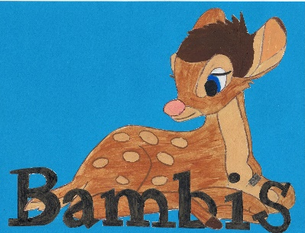

Live~Laugh~Love

Disciplinary procedure

At Bambi’s Childcare we follow our legal obligations as an employer at all times including dealing with any disciplinary matter in a fair and consistent manner. We have a policy and procedure that set out our process.

Legal obligations
Our legal obligations as an employer are detailed in the ACAS Code of Practice on disciplinary and grievance procedures. This code of practice was introduced on 6 April 2009. A full copy of the ACAS Code of Practice and the accompanying guidance can be obtained from the ACAS website www.acas.org.uk.

Disciplinary penalties
In the first instance, where less serious offences are concerned, we will give a verbal warning. This warning will be recorded and a copy maintained in the employee’s personnel file with a time scale for improvement or to not re-offend.

If further action becomes necessary and there is already an active warning on your record, or the misconduct is sufficiently serious, we will give a written warning. This warning will be recorded and a copy maintained in the employee’s personnel file for 1 year.

If the employee continues to fail to meet the required standards and there is already an active written warning on record, or the misconduct is sufficiently serious, we will issue a final written warning indicating that further behavior of a similar nature within a specified time period could result in dismissal. This warning will be recorded and a copy maintained in the employee’s personnel file for a specified period of time.

In conjunction with the early year’s statutory framework, section 3, 3.15, a person may be disqualified because they live in the same household as another person who is disqualified or where a disqualified person is employed.

Examples of misconduct
Examples of what would constitute a misconduct offence include:
- Minor breaches of our policies [including the Sickness Absence Policy, Mobile Phone and Social Networking Policy, and Health and Safety Policy]
- Minor breaches of your contract
- Damage to, or unauthorised use of, our property
- Poor timekeeping
- Time wasting
- Unauthorised absence from work/unacceptable attendance levels
- Refusal to follow instructions
- Excessive use of our telephones for personal calls
- Excessive personal email or internet usage
- Obscene language or other offensive behavior
- Negligence in the performance of your duties
- Smoking in no smoking areas.

Examples of gross misconduct
Examples of what would constitute a gross misconduct offence include:
- Failure to inform the employer of a disqualification, either personally or a person living in the same household as the registered provider, or a person employed in that household
- Theft or the unauthorised possession of property belonging to the nursery, its employees or customers
- Assault on any employee or persons associated with the nursery
- Breach of confidence i.e. the divulging of confidential information relating to the nursery, its employees or clients
- Dishonesty, including the use of any funds, expenses or allowances for any other purpose than that for which they have been delegated by the nursery
- Being under the influence of drugs or alcohol whilst on duty
- Serious or persistent breaches of safety rules
- Fraud including falsification of work records and expense claims
- Signing/clocking in or out for another employee
- Physical assault or abuse towards a child e.g. hitting a child in chastisement or harsh disciplinary actions
- Discrimination/harassment in any way against a person
- Persistent failure to follow nursery documentary systems and procedures.

Further behavior that could constitute gross misconduct is not limited by the above list.

