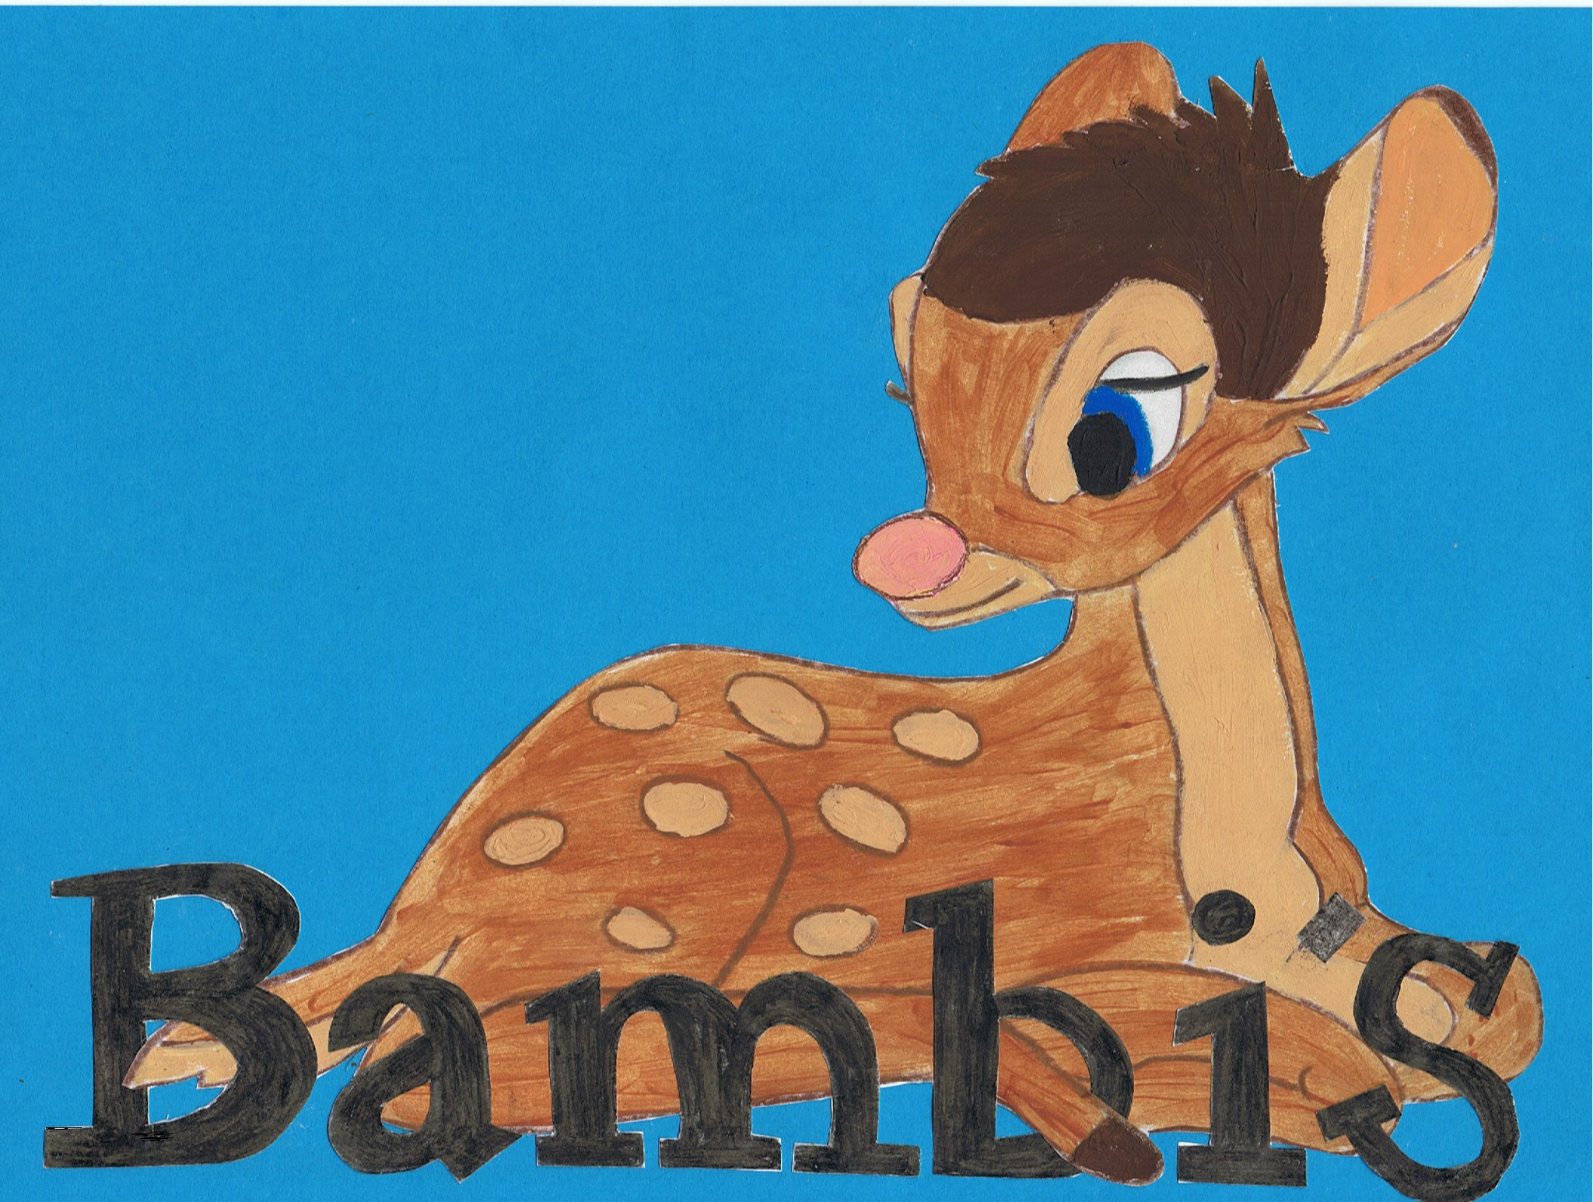

Live~Laugh~Love
Bullying

Bambi’s childcare is a small setting that promotes friendly and family values and will not tolerate bullying of any kind. Bullying may be perpetrated by one person or group of people. Bullying is defined as deliberate hurtful behaviour, usually repeated over a period of time, where it is difficult for those bullied to defend themselves. Bullying can be split into the following categories:
- Emotional - being unfriendly, excluding, tormenting (e.g. hiding belongings, threatening gestures)
- Physical - pushing, kicking, hitting, punching or any use of violence
- Racist - racial taunts, graffiti, gestures
- Sexual - unwanted physical contact or sexually abusive comments
- Homophobic - because of, or focusing on the issue of sexuality
- Verbal - name-calling, sarcasm, spreading rumours, teasing
- Cyber - all areas of internet, such as email & internet chat room misuse, mobile threats by text messaging & calls. Misuse of associated technology, e.g. camera & video facilities

The procedure for dealing with any bullying is as follows;
- A full investigation into the allegation
- A verbal warning to the perpetrator/s
- The situation will be monitored for two weeks, if after this time the bullying is still happening a written warning will be given.
- The situation will again be monitored for another 2 weeks, if after this time the bullying is still occurring then immediate dismissal will take place.
The above procedure will count for all types of bullying except in the cases of a Physical violent assault carried out on another person or in front of children; this will lead to immediate dismissal without a verbal or written warning.

