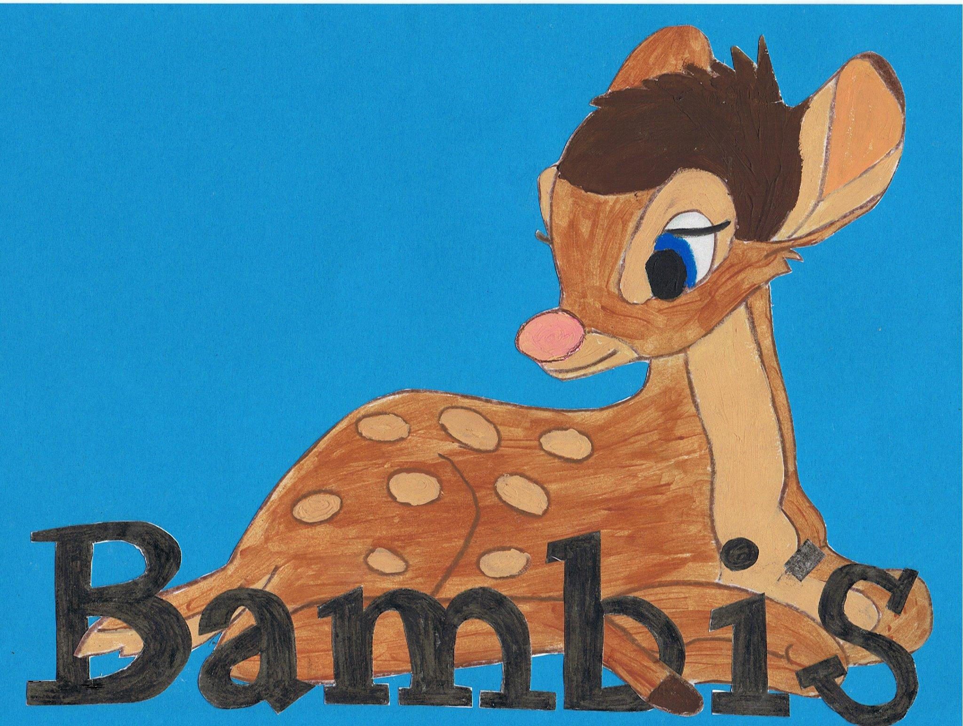

Live~Laugh~Love

Behavior management Policy

Bambi’s Childcare believes that children flourish best when their personal, social and emotional needs are met and they feel safe and secure in their environment. We also believe that where there are clear and developmentally appropriate expectations their behavior is positive.
We aim to teach our values and aims and also embed British values;
- to be kind to one another
- treat people fairly,
- Accept people for who they are and about having choices.
We also promote our motto Live~laugh~love where we can. ☺

We require all staff, volunteers and students to provide a positive model of behavior by treating children, parents and one another with friendliness, care and courtesy and to continue to promote our values and embedding British values.

We take working in partnership with children's parents seriously. Parents are regularly informed about their children's positive and negative behavior by their key person. We will work with parents to address any behavior and will use our observation records to help us to understand the cause and to decide jointly how to respond appropriately to any negative behavior. We aim to use pro-active strategies to promote positive behavior in children, and set these strategies within our programme for personal, social and emotional development. Bambi’s will continue to recognize that all children are individuals and respond to different methods, eg distraction and talking to the children so they understand any negative behavior.

Bambi’s Childcare will not use corporal punishment and will not let any other persons use it. It is seen as an offence if it is used and practitioners will be dealt with accordingly. The only circumstance where it will not be deemed as an offence is when physical intervention is taken for the purpose of averting immediate danger of personal injury to any persons or to manage a child’s behavior. This action must be recorded.

